MINISTRY OF SCIENCE AND EDUCATION NATIONAL TECHNICAL UNIVERSITY “KHARKIV POLYTECHNIC INSTITUTE”

DEPARTMENT OF SOFTWARE ENGINEERING AND MANAGEMENT INFORMATION TECHNOLOGIES

Report from lab#5

Discipline “Software Architecture ”

Executed by: Student of group 1.КН201.8ei1

CHUKWU IRELE AMORIN

Checked by:

Prof. Khtasko

Task : Sequence

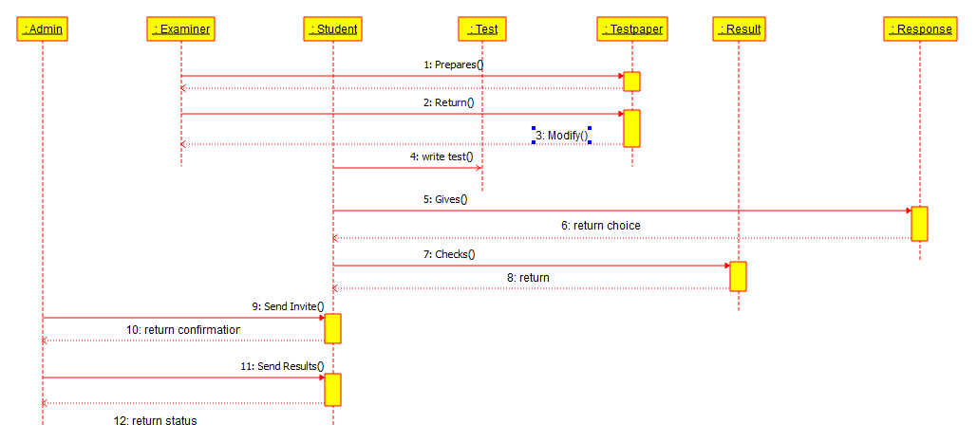

Sequence Diagram : Examination System

The Examination System is a system that show the process of an examination on a course between the admin , the examiner and the student taking the exams . The examiner creates and the test Paper, and can also modify the test paper before the student take the test. The student takes the test the examiner has created and submit back to the examiner. The student can later check is result from the response from the examiner. The result is sent to the Admin and he invites the student to confirm the results of the test

The sequence diagram show the flow of the process between various entities with various methods and operations